Whatcom County Fire District 4
Board of Fire Commissioners
Special Meeting Agenda

June 4, 2020
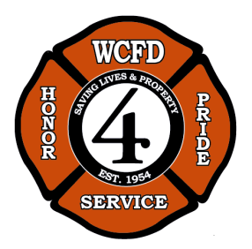

CALL TO ORDER/ATTENDANCE

- Appointment of legal counsel

- Meeting with NWFR to discuss the current ILA

- Update on WSRB

- Rental letter and Station 12 inspection

ANNOUNCEMENTS
Next Board Meeting: June 16, 2020 at 12pm.

ADJOURNMENT

